

Johanan Seeruthen

G00419446

Smart Glasses

BEng(H) in Software & Electronic Engineering

**Module:** Project Engineering

**Supervisor:** Niall O’Keeffe

**Institution:** Atlantic Technological University

2025-2026

# Project Description:

My final project idea is smart glasses which stemmed from the movie “Iron Man” in which Tony Stark made smart glasses. This was the catalyst that made me go back to the reason I wanted to become a software engineer, bringing me one step closer to being like Tony Stark.

The project will have a Raspberry Pi Zero 2 W that will act as the main controller to accommodate all the components and system code that is required. I choose this development board as upon researching micro-controllers I found out that this specific Raspberry Pi is small and powerful enough to support my project.

I will also have a Raspberry Pi Camera Module 3 that will be used to take photos and videos via a voice command. From my research the photos are gotten by converting light into electrical signals using its IMX708 12 megapixel sensor, which then converts it into a digital image. The voice prompts will be received using an Infineon MEMS microphone which will also allow you to ask queries on a variety of different things such as “what’s the weather like today” that an AI will answer. The microphone according to the Raspberry Pi form uses PDM to get sound frequency and display on an OLED display that is connected to the glass lens.

There will also be an app to aid the user and allow the user to have a easier time operating the smart glasses. It will display your location, the photos/videos you’ve taken and the AI question responses. Additionally, to turn it on and off the glasses it will use a button. I will use Mongo DB to store the responses and the photos and videos.

The challenges that I would face would be building an app and configuring the Raspberry Pi as well as ensuring that all the components correspond well together. That being said, I have no prior knowledge on how to go about this which will definitely prove challenging. If I have additional time at the end, I will try to incorporate a method in which, if you ask how to get to a certain location that it would show arrows on the display on how to get there. Another feature I will look at adding if there is time left is an auto translation feature that translates what you are looking at upon request.

# Timeline:

# A computer screen shot of a cell phone AI-generated content may be incorrect.A close-up of a calendarArchitecture Diagram:

# Hardware & Software:

|  |  |
| --- | --- |
| Hardware: | Software: |
| Push button | Python – primary language for Raspberry Pi |
| Infineon MEMS mic | Bash/Linux tool- for managing Pi OS and drivers |
| Camera Module 3 | React Native- for user app |
| GNSS module | MongoDB- database for Storring information |
| OLED display |  |
| Raspberry Pi Zero 2 W |  |

# Project Plan:

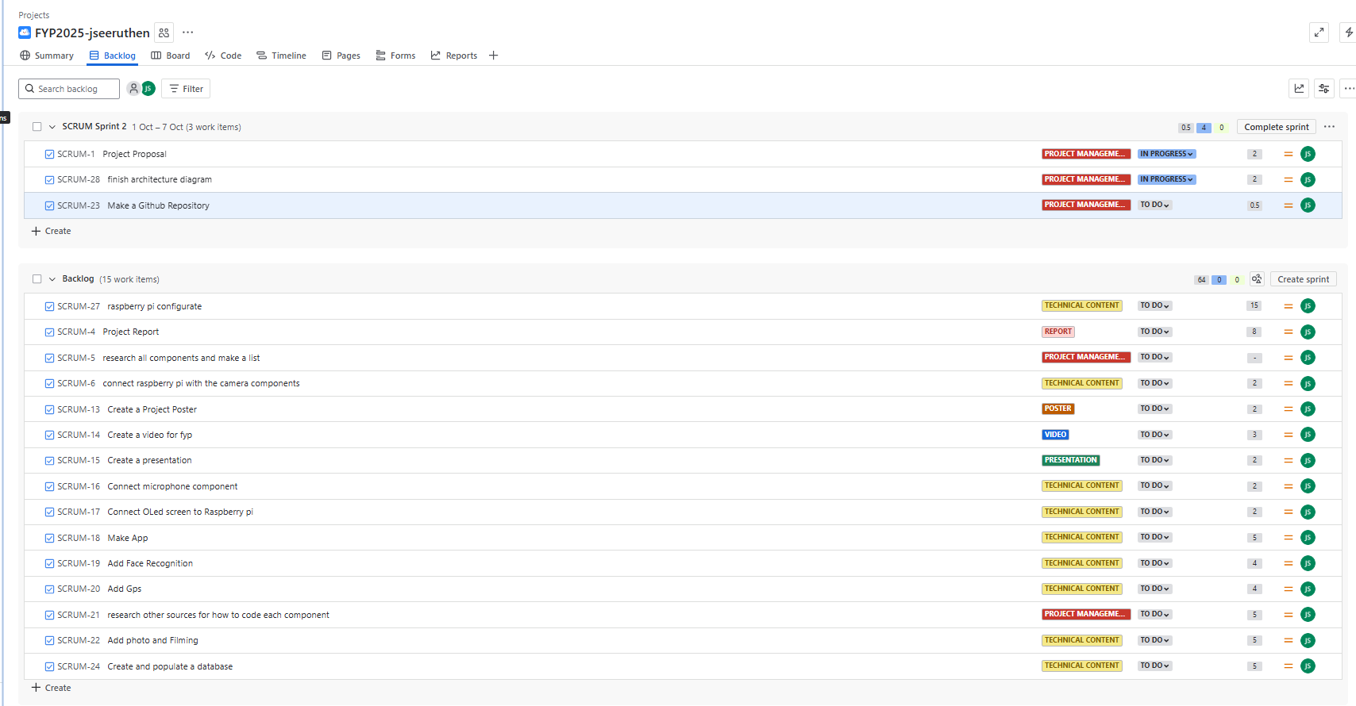Underneath I have outline all the tasks I will need to cover in order to complete the project, I have dedicated points to each task (1 point = 1 hour). I have also subcategorised them into different headings to make it easier to follow. Each sprint will be about 1 week long. And it will cover a number of tasks depending on priority level.

# Similar Projects:

[DIY Working E.D.I.T.H SMART GLASSES](https://youtu.be/Sj9ZQ20cgLA?si=sPpEiBRc3i6ucktp)

[Making a real life E.D.I.T.H smart glasses](https://youtu.be/LdCGzXsA870?si=sJBpJSph2VaKfihu)